EpiData EpiData is a program for DataEntry.
EpiData works on Machintosh Computers with RealPc Emulator and PC´s with Windows 95/98/NT/2000/ME/XP. Linux variants which can run Wine

For more information: www.epidata.dk
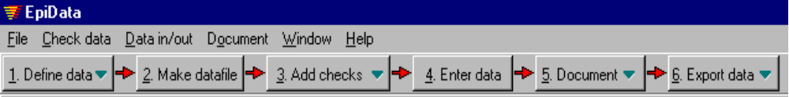The work process is as this (optional parts are dotted):
Define checks and jumps
- attach labels to variables
- range checks
- define conditional jumps (filters)
- consistency checks across variables

Attach labels to values
- Reuse from collection
- Define new

Define values as missing value
Change structure or layout when necessary
refine structure

Preview DataForm and simulate dataentry

When satisfied with layout create datafile

Define datastructure and layout of DataEntry

Enter all the data.
Enter data twice and compare directly at entry or enter separately and compare afterwards.
Generate documentation:
List of data, codebook and variable overview including defined checks and labels
Dataset is ready.
- archive copy with
documentation.
- export data for
special analysis
- analyse with EpiData Analysis
Correct errors based on original paper forms
Create datafile

Revise structure without loosing data

Developed and released by :
JM.Lauritsen & Bruus M
EpiData Association, Odense Denmark

